**ASSIGNMENT :1**

**TASK:1**

**Create a GIT repository named as your enrollment number. Create 2 folder in your repository named as Assignment_1 and Assignment_2. Prepare a word file which contains each steps of this task.**

**Upload your assignments in the respective folders. Share your git repository link in a google form asked you at the time of submission.**

**STEP 1:** Open your browser and search for github.com.

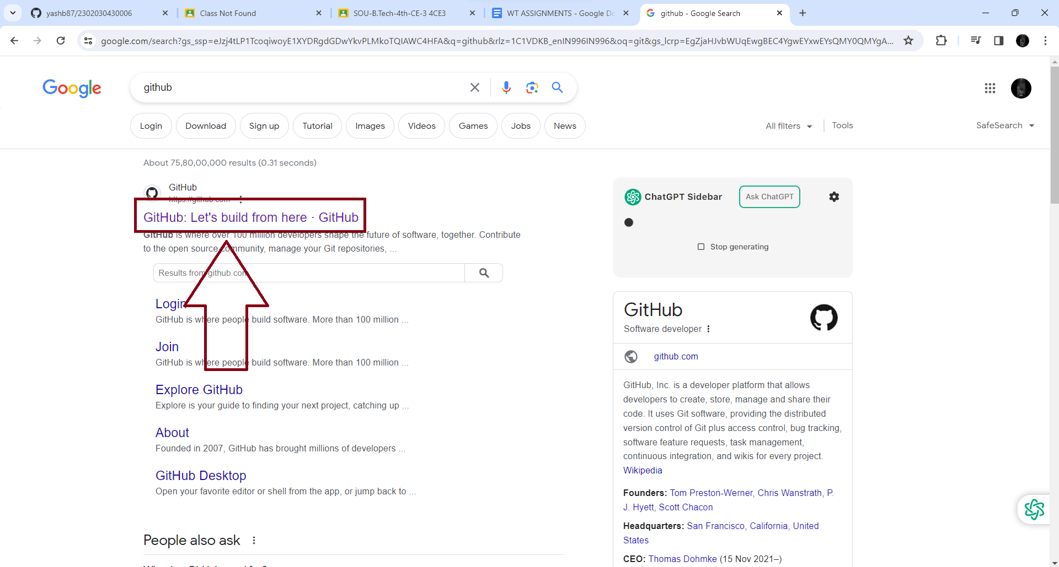

**STEP 2:** Now Login or Sign up.

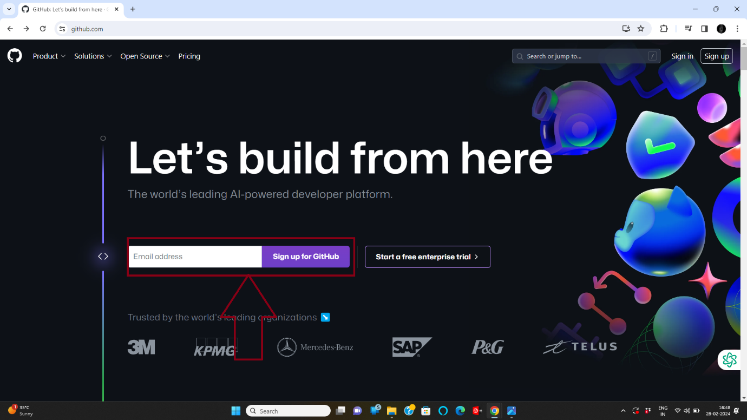

**STEP 3:** Now click on “create a new repository”.

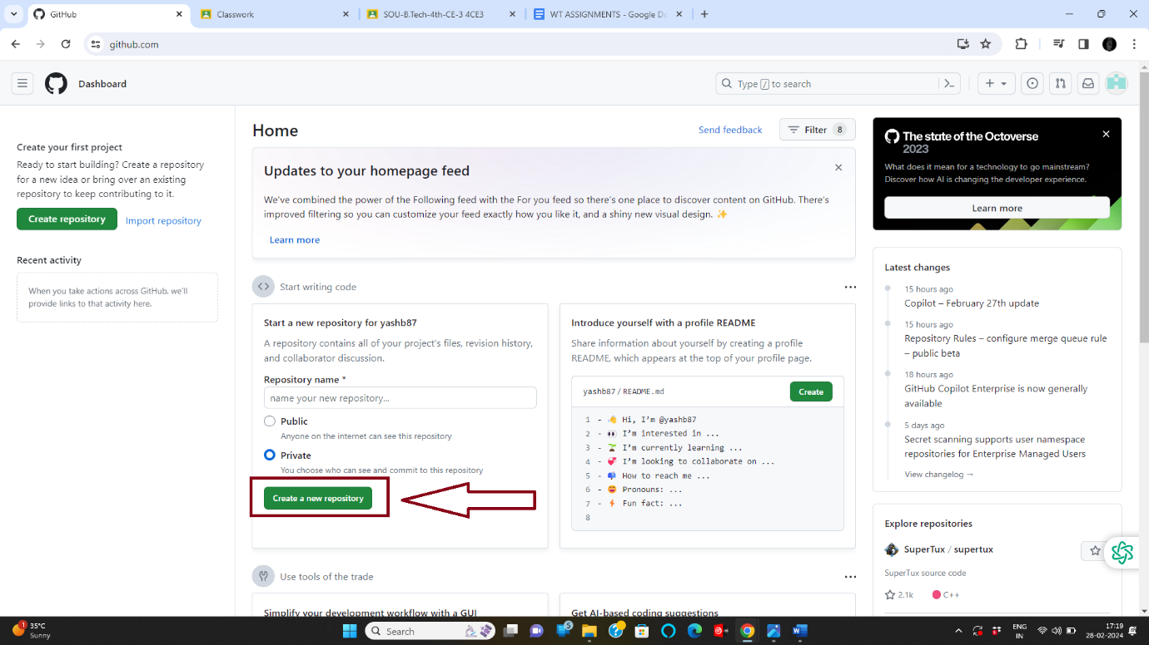

**STEP 4:** Now click on “Repository name” and write your enrolment number.

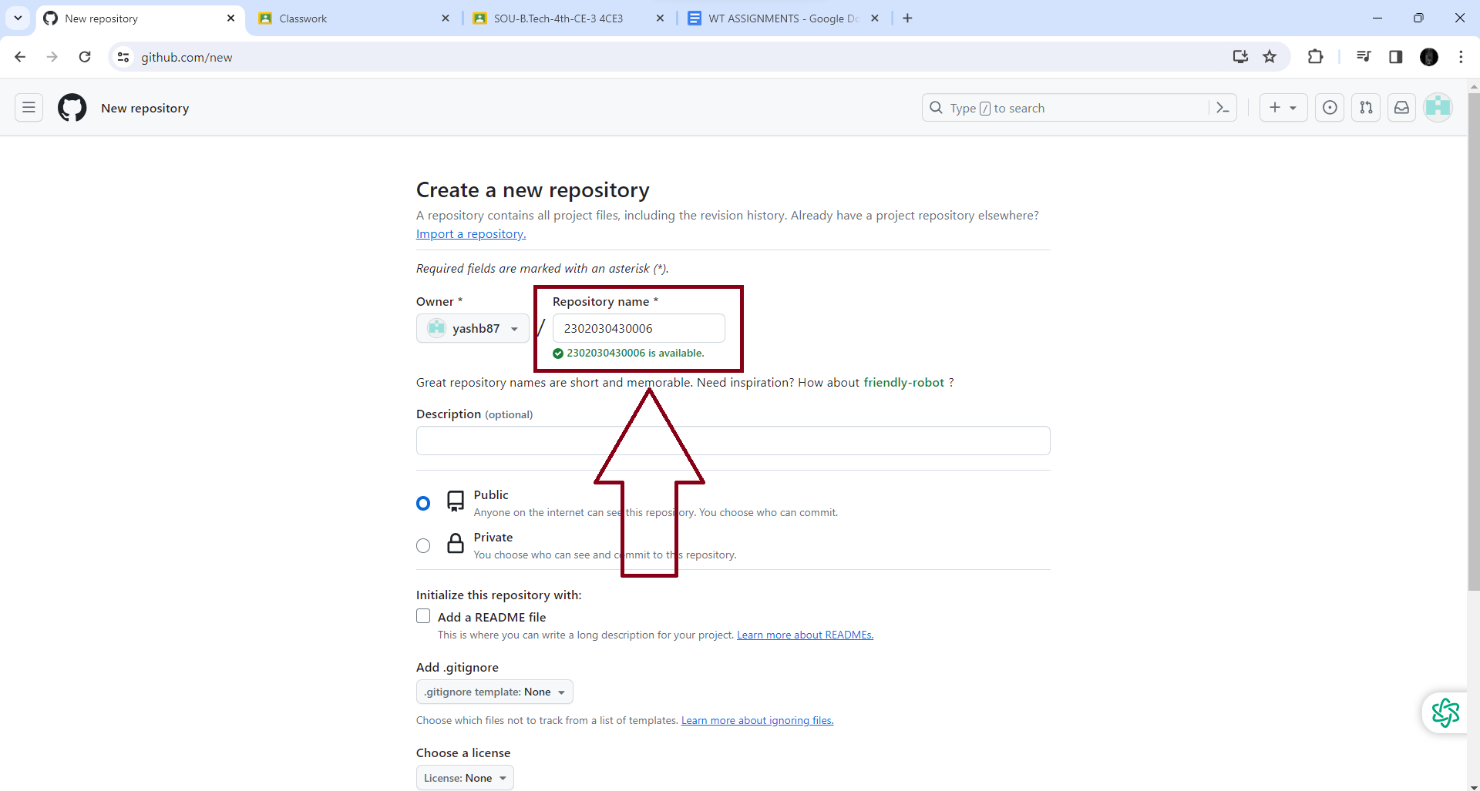

**STEP 5:** Now click on “Create Repository”.

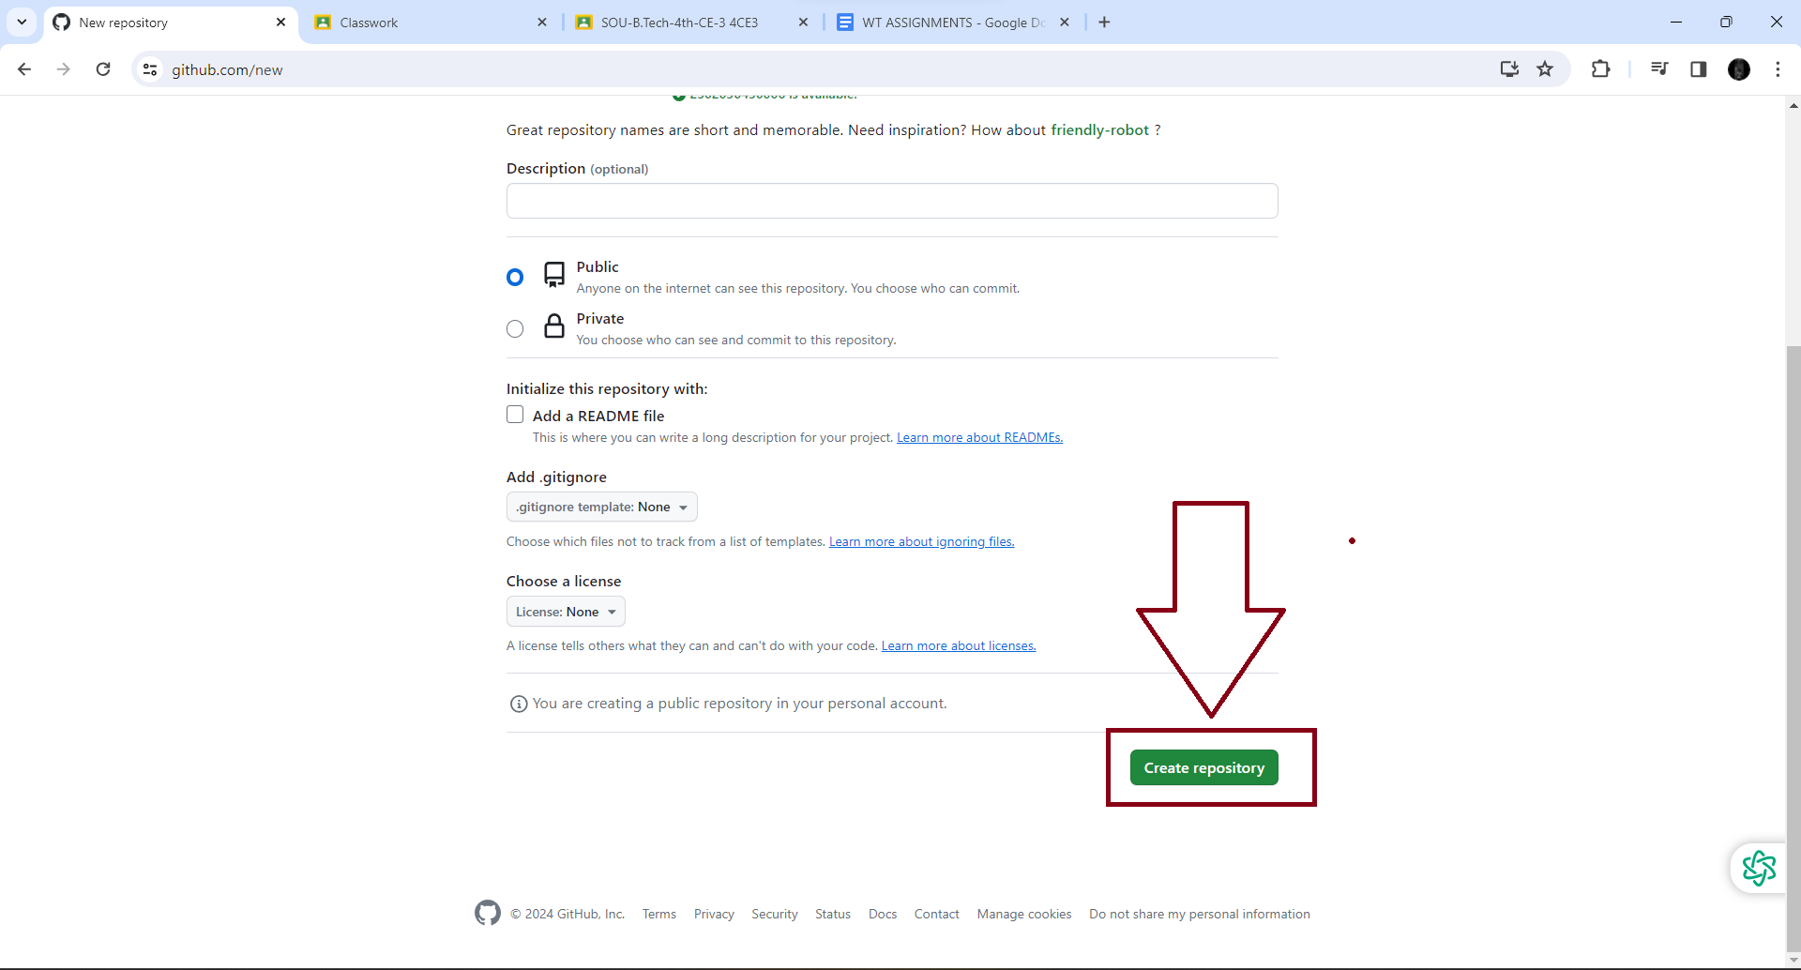

**STEP 6:** Now click on “Create a new file” to create new Folders.

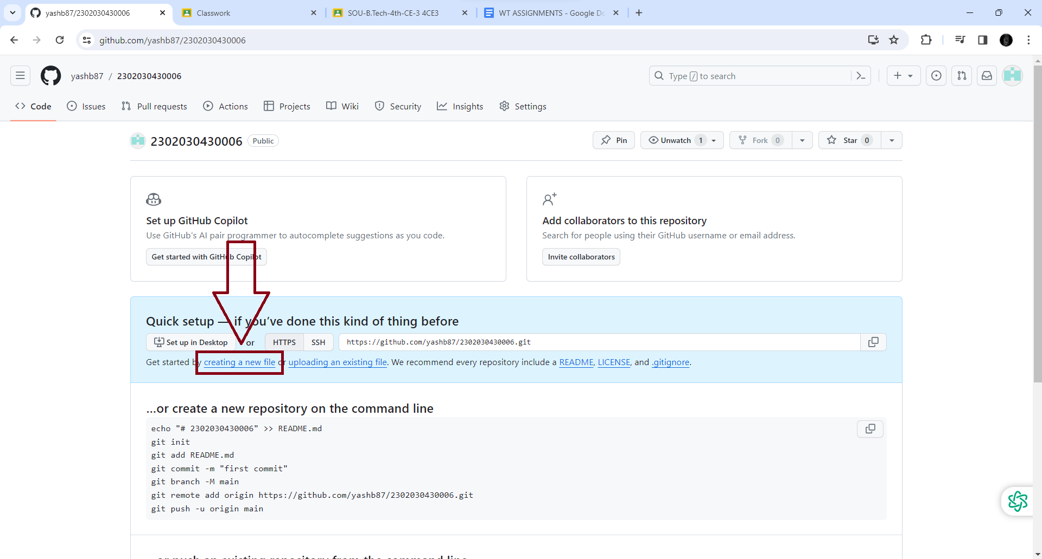

**STEP 7:** Now give “Assignment 1” name your folder, and click on “Commit changes” to create folder.

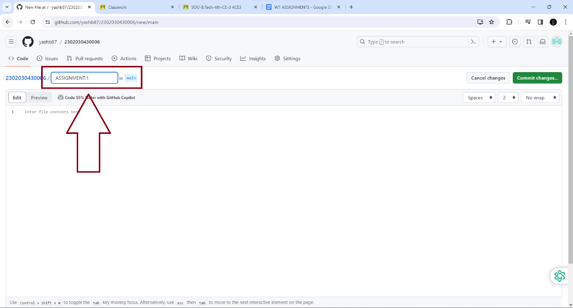

**STEP 8 :** Now click on “Add file” and then click on “Create new file”.

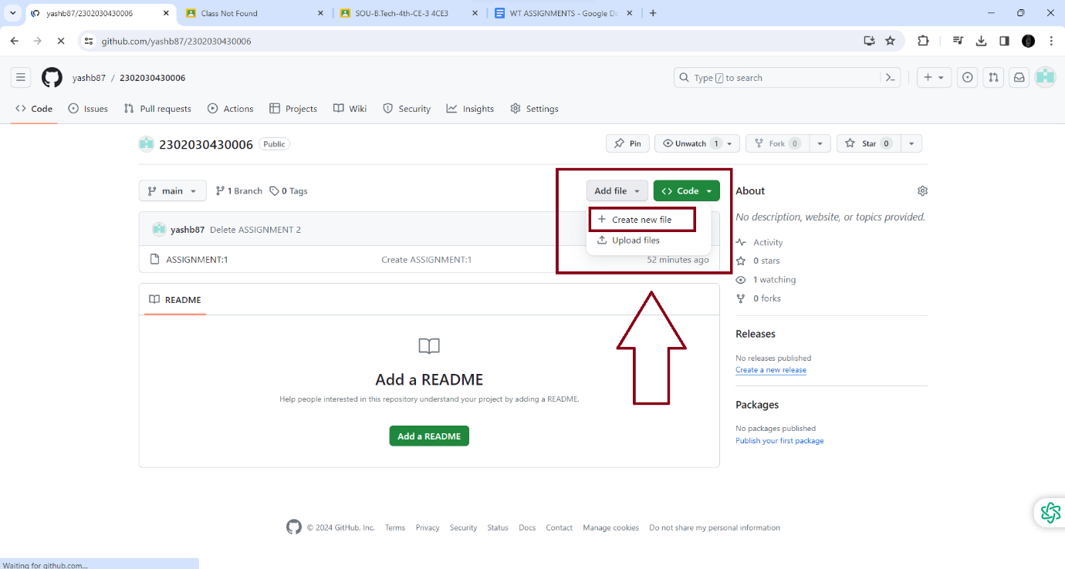

**Step 9:** Now give “Assignment 2” name your folder, and click on “Commit changes” to create folder.

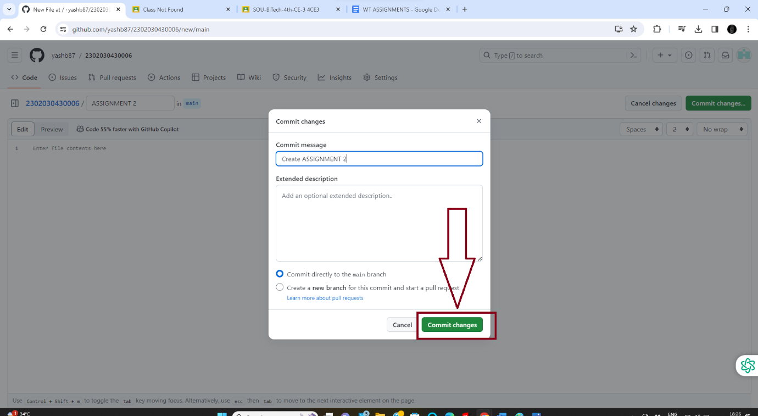

**STEP 10:** That’s how you can create folders in github.

